**P9.5** (LO 2, 3, 5) At December 31, 2019, Jimenez Enterprises reported the following as plant assets.

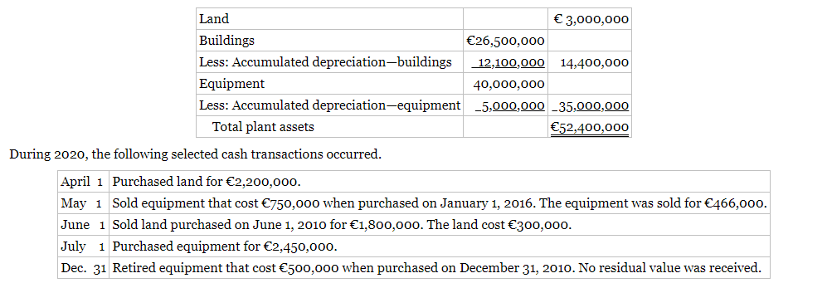

**Instructions**

a. Journalize the above transactions. The company uses straight‐line depreciation for buildings and equipment. The buildings are estimated to have a 50‐year life and no residual value. The equipment is estimated to have a 10‐year useful life and no residual value. Update depreciation on assets disposed of at the time of sale or retirement.

b. Record adjusting entries for depreciation for 2020.

c. Prepare the plant assets section of Jimenez's statement of financial position at December 31, 2020.

(a) Apr. 1 Land 2,200,000

Cash 2,200,000

May 1 Depreciation Expense    25,000

Accumulated Depreciation—

  Equipment

  (€750,000 X 1/10 X 4/12) 25,000

1 Cash   466,000

Accumulated Depreciation—

  Equipment   325,000

Equipment   750,000

Gain on Disposal of

  Plant Assets    41,000

Cost €750,000

Accum. depreciation—

  equipment 325,000

   [(€750,000 X 1/10 X 4)   
 + €25,000]

Book value  425,000

Cash proceeds 466,000

Gain on disposal € 41,000

June 1 Cash 1,800,000

Land   300,000

Gain on Disposal of

  Plant Assets 1,500,000

July 1 Equipment 2,450,000

Cash 2,450,000

Dec. 31 Depreciation Expense    50,000

Accumulated Depreciation—

  Equipment

  (€500,000 X 1/10) 50,000

31 Accumulated Depreciation—

  Equipment   500,000

Equipment   500,000

Cost €500,000

Accum. depreciation—

  equipment  500,000

  (€500,000 X 1/10 X 10)

Book value € 0

(b) Dec. 31 Depreciation Expense   530,000

Accumulated Depreciation—

  Buildings   530,000

  (€26,500,000 X 1/50)

31 Depreciation Expense 3,997,500

Accumulated Depreciation—

  Equipment 3,997,500

(€38,750,000* X 1/10) €3,875,000

[(€2,450,000 X 1/10) X 6/12] 122,500

€3,997,500

*(€40,000,000 – €750,000 – €500,000)

(c) JIMENEZ ENTERPRISES

Partial Statement of Financial Position

December 31, 2020

Plant Assets*

Land € 4,900,000

Buildings €26,500,000

Less: Accumulated depreciation—

buildings 12,630,000  13,870,000

Equipment  41,200,000

Less: Accumulated depreciation—

equipment 8,247,500 32,952,500

Total plant assets €51,722,500

*See T-accounts which follow.

PROBLEM 9.5 (Continued)

|  |  |
| --- | --- |
| Land | |
| Bal.  3,000,000  Apr. 1  2,200,000 | June 1    300,000 |
| Bal.  4,900,000 |  |

|  |  |
| --- | --- |
| Buildings | |
| Bal. 26,500,000 |  |
| Bal. 26,500,000 |  |

|  |  |
| --- | --- |
| Accumulated Depreciation—Buildings | |
|  | Bal. 12,100,000  Dec. 31 adj.    530,000 |
|  | Bal. 12,630,000 |

|  |  |
| --- | --- |
| Equipment | |
| Bal. 40,000,000  July 1  2,450,000 | May 1    750,000  Dec. 31    500,000 |
| Bal. 41,200,000 |  |

|  |  |
| --- | --- |
| Accumulated Depreciation—Equipment | |
| May 1    325,000  Dec. 31    500,000 | Bal.  5,000,000  May 1     25,000  Dec. 31     50,000  Dec. 31 adj.  3,997,500 |
|  | Bal.  8,247,500 |

**P11.5 (LO 2, 5)** On January 1, 2020, Lock Industries Ltd. issued ￡1,800,000 face value, 5%, 10-year bonds at ￡1,667,518. This price resulted in an effective-interest rate of 6% on the bonds. Lock uses the effective-interest method to amortize bond premium or discount. The bonds pay annual interest January 1.

|  |  |  |  |  |  |  |  |  |  |
| --- | --- | --- | --- | --- | --- | --- | --- | --- | --- |
| **Instructions** (Round all computations to the nearest pound.) |  |  |  |  |  |  |  |  |  |
| **a.** Prepare the journal entry to record the issuance of the bonds on January 1, 2020. | | | | | |  |  |  |  |
| **b.** Prepare an amortization table through December 31, 2022 (3 interest periods) for this bond issue. | | | | | | | |  |  |
| **c.** Prepare the journal entry to record the accrual of interest and the amortization of the discount on December 31, 2020. | | | | | | | | | |
| **d.** Prepare the journal entry to record the payment of interest on January 1, 2021. | | | | | |  |  |  |  |
| **e.** Prepare the journal entry to record the accrual of interest and the amortization of the discount on December 31, 2021 | | | | | | | | | |

2020

(a) Jan. 1 Cash 1,667,518

Bonds Payable 1,667,518

(b) LOCK INDUSTRIES LTD.

Bond Discount Amortization

Effective-Interest Method—Annual Interest Payments

5% Bonds Issued at 6%

|  |  |  |  |  |  |  |  |  |
| --- | --- | --- | --- | --- | --- | --- | --- | --- |
| Annual  Interest  Periods |  | (A)  Interest  to Be  Paid |  | (B)  Interest  Expense  to Be  Recorded |  | (C)  Discount  Amor-  tization  (B) – (A) |  | (D)  Bond  Carrying  Value |
|  |  |  |  |  |  |  |  |  |
| Issue date  1  2  3 |  | £90,000   90,000   90,000 |  | £100,051  100,654  101,293 |  | £10,051   10,654   11,293 |  | £1,667,518   1,677,569   1,688,223   1,699,516 |

2020

(c) Dec. 31 Interest Expense

  (£1,667,518 X 6%) 100,051

Interest Payable

  (£1,800,000 X 5%) 90,000

Bonds Payable  10,051

2021

(d) Jan. 1 Interest Payable 90,000

Cash 90,000

(e) Dec. 31 Interest Expense

  [(£1,667,518 + £10,051) X 6%] 100,654

Interest Payable 90,000

Bonds Payable  10,654

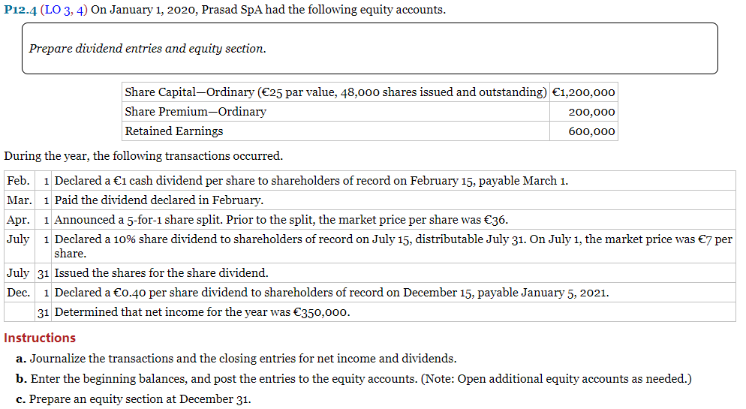

(a) Feb.  1 Cash Dividends (48,000 X €1)  48,000

Dividends Payable  48,000

Mar.  1 Dividends Payable  48,000

Cash  48,000

Apr.  1 Memo—five-for-one share split   
   increases number of shares to   
   240,000 = (48,000 X 5) and reduces   
   par value to €5 per share.

July  1 Share Dividends (24,000 X €7) 168,000

Ordinary Share Dividends

  Distributable (24,000 X €5) 120,000

Share Premium—Ordinary

  (24,000 X €2) 48,000

31 Ordinary Share Dividends

  Distributable 120,000

Share Capital—Ordinary 120,000

Dec.  1 Cash Dividends (264,000 X €.40) 105,600

Dividends Payable 105,600

31 Income Summary 350,000

Retained Earnings 350,000

Retained Earnings 168,000

Share Dividends 168,000

Retained Earnings 153,600

Cash Dividends 153,600

(b)

Share Capital—Ordinary

|  |  |  |  |  |  |  |  |  |  |  |
| --- | --- | --- | --- | --- | --- | --- | --- | --- | --- | --- |
| Date |  | Explanation |  | Ref. |  | Debit |  | Credit |  | Balance |
| Jan.  1  Apr.  1  July 31 |  | Balance  5 for 1 split—new    par €5 |  |  |  |  |  | 120,000 |  | 1,200,000  1,320,000 |

Ordinary Share Dividends Distributable

|  |  |  |  |  |  |  |  |  |  |  |
| --- | --- | --- | --- | --- | --- | --- | --- | --- | --- | --- |
| Date |  | Explanation |  | Ref. |  | Debit |  | Credit |  | Balance |
| July  1  31 |  |  |  |  |  | 120,000 |  | 120,000 |  | 120,000        0 |

Share Premium—Ordinary

|  |  |  |  |  |  |  |  |  |  |  |
| --- | --- | --- | --- | --- | --- | --- | --- | --- | --- | --- |
| Date |  | Explanation |  | Ref. |  | Debit |  | Credit |  | Balance |
| Jan.  1  July  1 |  | Balance |  |  |  |  |  | 48,000 |  | 200,000  248,000 |

Retained Earnings

|  |  |  |  |  |  |  |  |  |  |  |
| --- | --- | --- | --- | --- | --- | --- | --- | --- | --- | --- |
| Date |  | Explanation |  | Ref. |  | Debit |  | Credit |  | Balance |
| Jan.  1  31 |  | Balance  Net income  Share dividend  Cash dividend |  |  |  | 168,000  153,600 |  | 350,000 |  | 600,000  950,000  782,000  628,400 |

Cash Dividends

|  |  |  |  |  |  |  |  |  |  |  |
| --- | --- | --- | --- | --- | --- | --- | --- | --- | --- | --- |
| Date |  | Explanation |  | Ref. |  | Debit |  | Credit |  | Balance |
| Feb.  1  Dec.  1  Dec. 31 |  |  |  |  |  | 48,000  105,600 |  | 153,600 |  | 48,000  153,600  0 |

Share Dividends

|  |  |  |  |  |  |  |  |  |  |  |
| --- | --- | --- | --- | --- | --- | --- | --- | --- | --- | --- |
| Date |  | Explanation |  | Ref. |  | Debit |  | Credit |  | Balance |
| July  1  Dec. 31 |  |  |  |  |  | 168,000 |  | 168,000 |  | 168,000        0 |

PROBLEM 12-4 (Continued)

(c) PRASAD SpA

Statement of Financial Position (Partial)

December 31, 2020

Equity

Share capital—ordinary, €5 par value, 264,000

  shares issued and outstanding €1,320,000

Share premium—ordinary 248,000

Retained earnings 628,400

Total equity €2,196,400

**P14.7** (LO 2, 3) Presented below are the financial statements of Rajesh Ltd.

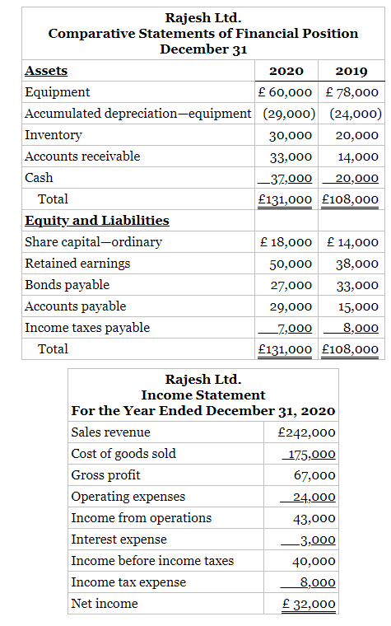

Additional data:

1. Depreciation expense is £13,300.

2. Dividends declared and paid were £20,000.

3. During the year, equipment was sold for £9,700 cash. This equipment cost £18,000 originally and had accumulated depreciation of £8,300 at the time of sale.

**Instructions**

1. Prepare a statement of cash flows using the indirect method.
2. Compute free cash flow.

(a) RAJESH LTD.

Statement of Cash Flows

For the Year Ended December 31, 2020

Cash flows from operating activities

Net income £32,000

Adjustments to reconcile net income

  to net cash provided by operating activities:

Depreciation expense £13,300

Increase in accounts receivable  (19,000)

Increase in inventory (10,000)

Increase in accounts payable  14,000

Decrease in income taxes payable   (1,000)   (2,700)

Net cash provided by operating activities 29,300

Cash flows from investing activities

Sale of equipment 9,700

Cash flows from financing activities

Issuance of ordinary shares 4,000

Redemption of bonds (6,000)

Payment of dividends  (20,000)

Net cash used by financing activities  (22,000)

Net increase in cash 17,000

Cash at beginning of period   20,000

Cash at end of period £37,000

(b) £29,300 – £0 – £20,000 = £9,300

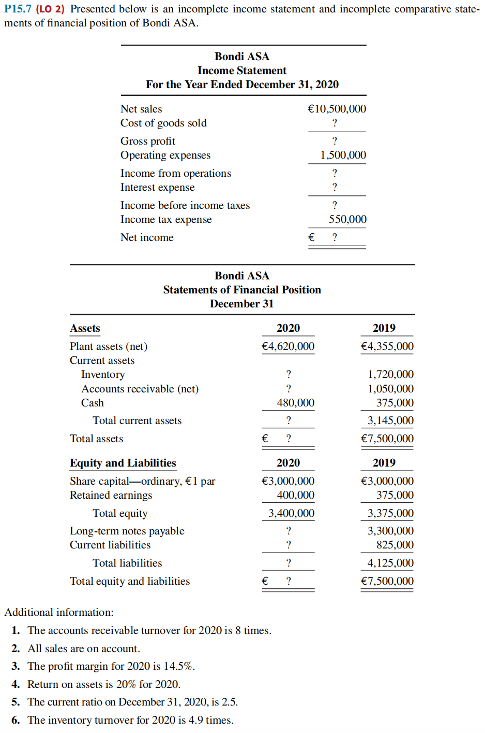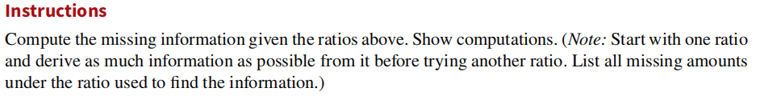

|  |
| --- |
| PROBLEM 15.7 |

Accounts receivable turnover = 8 = 

Average net accounts receivable =  = €1,312,500

 = €1,312,500

Net accounts receivable 12/31/20 + €1,050,000 = €2,625,000

Net accounts receivable 12/31/20 = €1,575,000

Profit margin = 14.5% = .145 = 

Net income = €10,500,000 X .145 = €1,522,500

Income before income taxes = €1,522,500 + €550,000 = €2,072,500

Return on assets = 20% = .20 = 

Average assets = €1,522,500 ÷ .20 = €7,612,500

 = €7,612,500

Assets (12/31/20) = €7,725,000

Total current assets = €7,725,000 – €4,620,000 = €3,105,000

Inventory = €3,105,000 – € 1,575,000 – €480,000 = €1,050,000

Total liabilities and equity = €7,725,000

Total liabilities = €7,725,000 – €3,400,000 = €4,325,000